Acceptance Testing
UAT Execution & Report Submission
Date: 07 September 2026
Team ID: ____________________
Project Name: Incident Lifecycle Automation in ServiceNow
Maximum Marks: 4 Marks

1. Purpose of Document
The purpose of this document is to briefly explain the UAT test coverage and open issues for the Incident Lifecycle Automation in ServiceNow project. Testing covers incident creation, classification, assignment, investigation, SLA monitoring, resolution and closure.
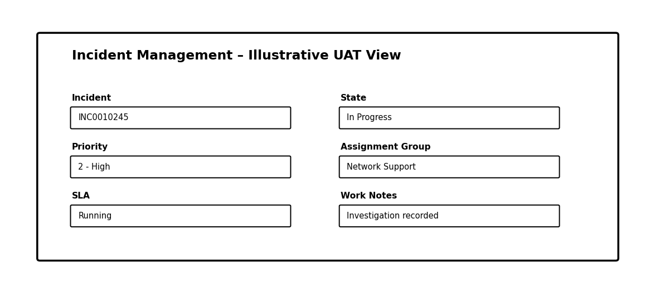
Figure 1: Illustrative ServiceNow incident record for UAT (not a live screenshot).

2. Defect Analysis
Resolution | Severity 1 | Severity 2 | Severity 3 | Severity 4 | Subtotal
By Design | 0 | 0 | 0 | 0 | 0
Duplicate | 0 | 0 | 0 | 0 | 0
External | 0 | 0 | 0 | 0 | 0
Fixed | 0 | 0 | 0 | 0 | 0
Not Reproduced | 0 | 0 | 0 | 0 | 0
Skipped | 0 | 0 | 0 | 0 | 0
Won't Fix | 0 | 0 | 0 | 0 | 0
Totals | 0 | 0 | 0 | 0 | 0
No actual defect results were supplied in the project description; therefore, no defect results have been invented.

3. Test Case Analysis
This report shows the planned UAT test cases for the major Incident Lifecycle Automation functions. Actual results can be entered after execution.
Section | Total Cases | Not Tested | Fail | Pass
Incident Creation & Classification | 3 | 3 | 0 | 0
Assignment & Reassignment | 2 | 2 | 0 | 0
Knowledge Management | 2 | 2 | 0 | 0
Level 2 Investigation & Resolution | 3 | 3 | 0 | 0
SLA & Escalation | 2 | 2 | 0 | 0
Emergency Change & Child Incident | 2 | 2 | 0 | 0
Knowledge Article Generation | 1 | 1 | 0 | 0
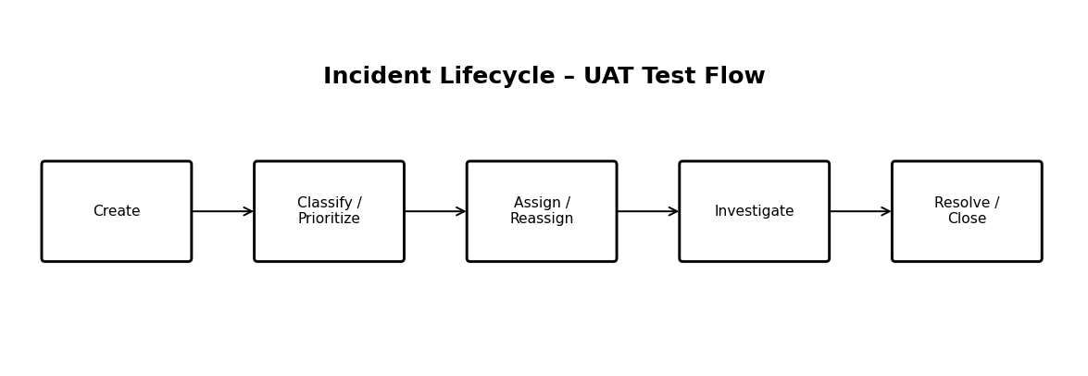
Figure 2: UAT test flow for the incident lifecycle.

UAT Coverage
The UAT scope follows the stated project goals: Service Desk incident creation and classification, Knowledge Management, reassignment to support groups, Level 2 investigation and resolution, emergency change requests, child incidents, knowledge article generation, and improved SLA/service visibility.

Open Issues / Final Report
No actual open issues or pass/fail results were supplied. This document therefore records planned coverage only. Update the results after executing the UAT cases.

